What Seattle Read During Covid: A Longitudinal Analysis of Seattle Public Library Borrowing Patterns (2018-2025)
Author: Stacey Mahuna
Abstract
Public libraries offer a useful lens for observing community behavior during disruption. This project analyzes Seattle Public Library circulation data from 2018-2025 across four periods: Pre-Covid, Covid, Recovery, and Post-Covid. The strongest shifts appeared in borrowing format rather than content: eBooks became dominant during Covid, physical circulation fell sharply, and digital borrowing remained elevated afterward. Top subject combinations stayed relatively stable, while thematic analysis showed a temporary Covid-era increase in African American-related materials and sustained growth in LGBTQIA+-related materials through the Post-Covid period. Overall, the findings suggest Covid accelerated a durable shift toward digital borrowing while broader reading preferences remained consistent.
1. Introduction
The Covid-19 pandemic disrupted daily life, including how people accessed public services. Public libraries played an important role during this period by providing information, education, entertainment, and cultural resources as physical spaces closed and digital services expanded.
This analysis examines Seattle Public Library circulation data from 2018-2025 to explore how aggregate borrowing behavior changed before, during, and after Covid.
The primary objective of this project is to determine whether borrowing behavior changed during the pandemic and, if so, whether those changes persisted after restrictions were lifted. Specifically, the analysis addresses the following questions:
- How did borrowing formats change before, during, and after the Covid-19 pandemic?
- Did patrons change the types of materials they borrowed, or primarily the formats through which they accessed those materials?
- Did selected subject themes, including LGBTQIA+-related and African American-related materials, exhibit meaningful changes in circulation over time?
2. Background and Related Work
Open library datasets make it possible to examine readership patterns, title popularity, collection use, and cultural trends over time. The Seattle Public Library dataset is especially useful because it combines circulation activity with catalog metadata across multiple years.
While many analyses focus on circulation broadly, fewer examine how borrowing changes during major disruptions. Covid provides a useful case for evaluating whether changes in library use were temporary or persistent.
3. Data and Methodology
3.1 Dataset
This analysis uses the Seattle Public Library Checkouts by Title dataset from the Seattle Open Data portal. The dataset includes monthly checkout counts for physical and digital items, along with metadata such as title, creator, material type, publication year, and subjects. As of July 2026, it contained approximately 51.3 million records.
3.2 Analysis Period
To evaluate the impact of Covid-19, circulation activity was grouped into four periods: Pre-Covid (2018-2019), Covid (2020-2021), Recovery (2022-2023), and Post-Covid (2024-2025). This structure provides a consistent basis for comparing behavior across stable, disruptive, and recovery periods.
3.3 Data Architecture
Because of the dataset’s size, data were staged into Bronze raw extracts, Silver cleaned data, and Gold reporting tables. DuckDB queried Parquet files directly to reduce memory needs and support efficient aggregation.
3.4 Measures
Three analytical dimensions were examined: borrowing format, ranked subject combinations, and two keyword-based thematic groups: LGBTQIA+-related and African American-related materials. Thematic circulation was normalized as a percentage of total monthly circulation to account for changes in overall checkout volume.
4. Results
4.1 Overall Circulation Trends
Monthly checkout volumes declined during Covid, recovered in 2022-2023, and eventually exceeded Pre-Covid levels. However, missing records tied to the 2024 ransomware incident create uncertainty in some Post-Covid calculations.
Fig.1, “SPL Monthly Checkouts, Pre-Covid to Post-Covid (2018-2025)”
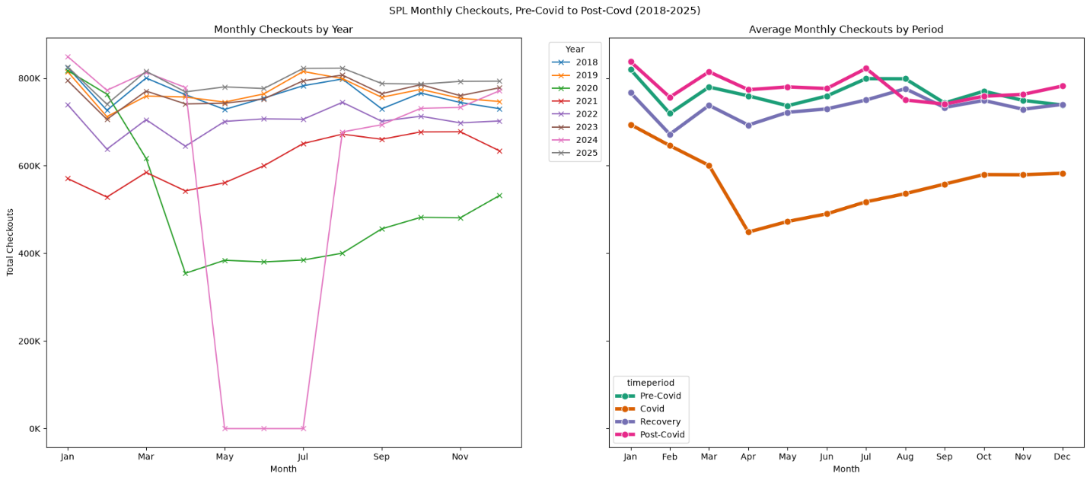
4.2 Material Type Trends
Material format experienced the largest shifts observed in the analysis.
Material format showed the largest shift. Before Covid, physical books accounted for the largest share of circulation. During Covid, eBooks became dominant and audiobooks increased. Digital formats retained higher shares during Recovery and Post-Covid, suggesting Covid accelerated an existing move toward digital borrowing.

Fig. 2, “Average Monthly SPL Checkouts by Material Type and Covid Period – Top 5 Material Types”
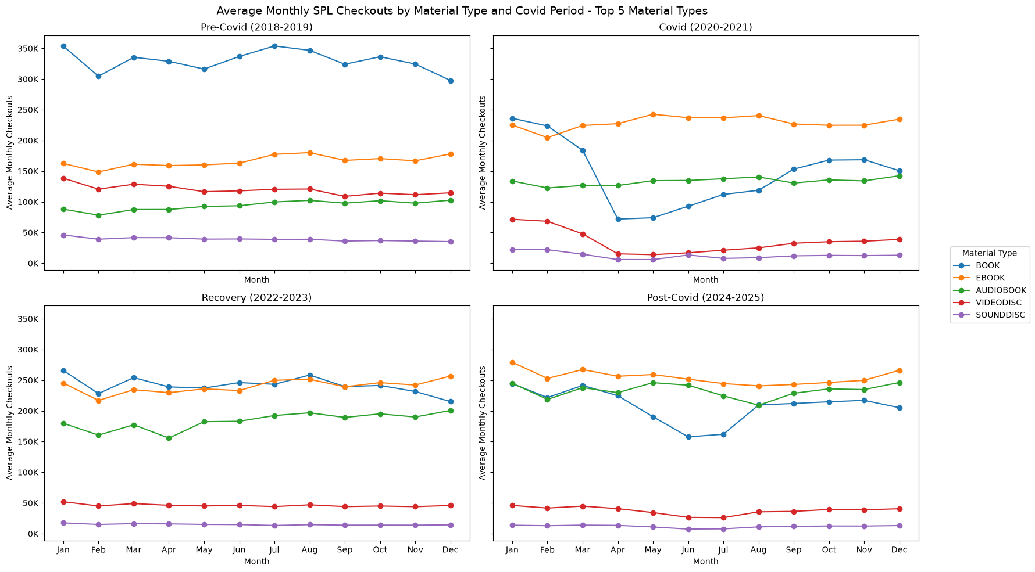Fig. 3, “Average Monthly Share of SPL Checkouts by Material Type and Covid Period (2018-2025)”
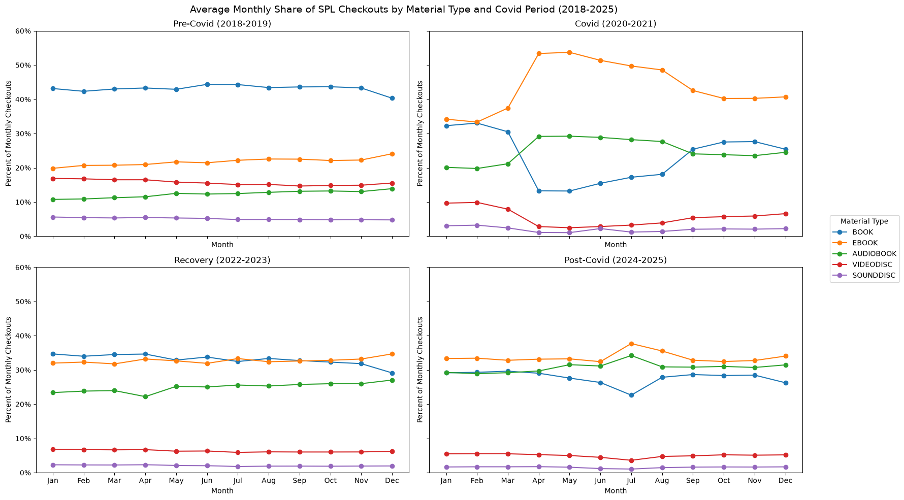
4.3 Subject Combination Trends
The most frequently borrowed subject combinations remained stable across all four periods, including fiction, literature, mystery, thriller, romance, and juvenile fiction. Rankings shifted slightly, but broad reading interests changed far less than borrowing formats. The disappearance of the Unknown category from top rankings may reflect improved metadata quality.
Fig. 4, “Top 10 Seattle Public Library Subject Combinations by Covid Period”
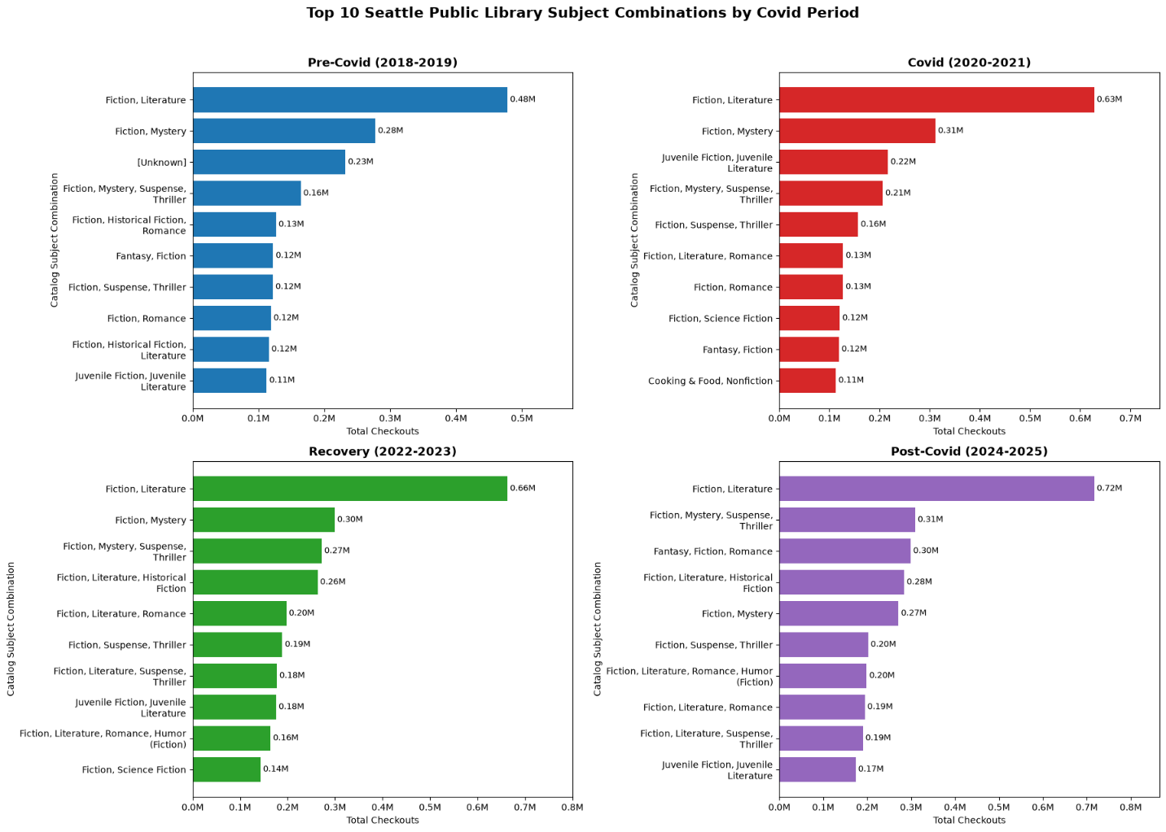
4.4 LGBTQIA+ and African American Themes
African American Materials
African American-related materials increased from approximately 1.84% of monthly circulation Pre-Covid to 2.67% during Covid, then returned close to baseline in Recovery and Post-Covid.
LGBTQIA+ Materials
LGBTQIA+-related materials followed a different pattern, increasing from approximately 0.57% Pre-Covid to 2.94% Post-Covid. Unlike African American-related materials, this growth persisted through Recovery and Post-Covid.
Fig. 5, “LGBTQIA+ and African American Subject Checkouts by Covid Period”
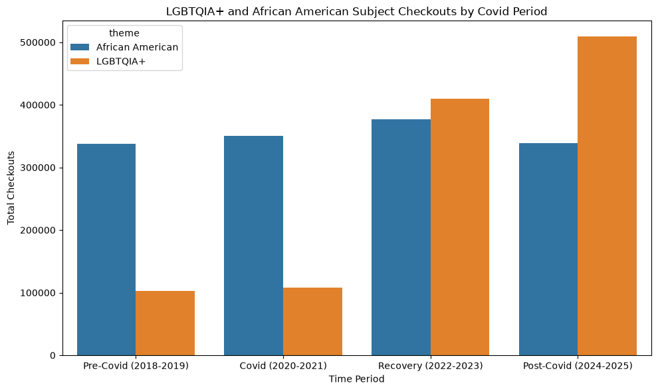Fig. 6, “Average Monthly Share of SPL Checkouts by Selected Subject Themes”
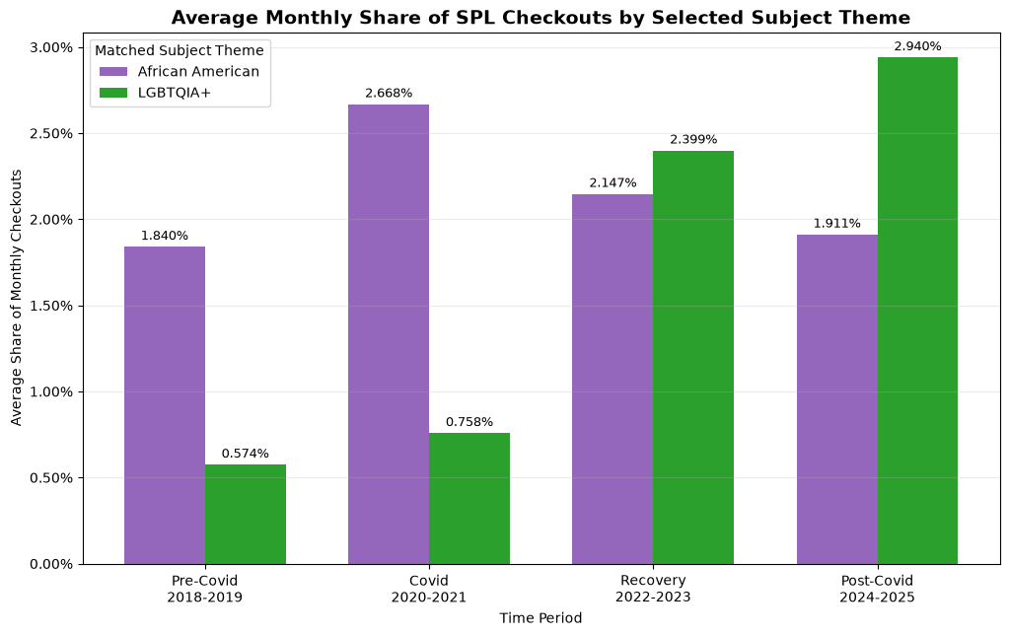
5. Discussion
The central finding is that patrons changed how they borrowed more than what they borrowed.
Covid produced a durable shift from physical to digital borrowing. eBooks and audiobooks gained circulation share during the pandemic and retained much of that gain afterward, suggesting acceleration of an existing digital trend rather than a short-term disruption.
At the same time, broad reading interests remained consistent. Fiction, mystery, romance, thriller, and juvenile fiction continued to dominate top subject combinations.
The thematic analysis adds nuance: LGBTQIA+-related materials showed sustained growth, while African American-related materials showed a temporary Covid-era increase. Topic-specific views therefore reveal patterns not visible in aggregate totals.
6. Limitations
Several limitations should be considered when interpreting these findings:
- The Subjects field contains concatenated catalog metadata rather than a standardized genre taxonomy.
- Cataloging practices appear to have evolved over time, affecting metadata consistency.
- LGBTQIA+ and African American analyses relied on keyword matching and may not capture all relevant materials.
- Circulation reflects utilization of available resources rather than total demand.
- External factors such as collection development, operating hours, licensing restrictions, and marketing activities cannot be disentangled from circulation patterns.
- Missing records associated with the 2024 ransomware incident create uncertainty within portions of the Post-Covid period.
7. Future Work
Several directions could extend and strengthen the analysis:
- Develop a normalized subject taxonomy by decomposing concatenated subject strings into individual topic tags.
- Expand theme-based analyses to include mental health, personal finance, employment, climate, technology, and food-related materials.
- Conduct title-level analyses to identify which works are driving observed trends.
- Integrate circulation data with collection inventory to distinguish demand from availability.
- Extend the analysis period to include earlier disruptions such as the 2008 financial crisis and analyze the full 2006-2026 dataset.
8. Conclusion
Covid substantially changed Seattle Public Library borrowing behavior. The clearest shift was not in what patrons read, but in how they accessed materials: digital formats rose sharply and remained elevated after restrictions ended. Broad reading preferences stayed stable, while LGBTQIA+-related materials showed sustained growth across the analysis period. These findings suggest library circulation data can help reveal how communities adapt to disruption while preserving continuity in core reading interests.
References
- Seattle Public Library Checkouts by Title Dataset. Seattle Open Data Portal.
- Seattle Public Library’s Open Checkout Data: What Can It Tell Us About Readers and Book Popularity More Broadly?
- The Canon in Circulation: Tracking the Reception of Norton Anthology Authors in Library Checkout Data.
- Where Is All the Book Data?
Appendix A: Data Engineering Notes
- Data extracted using the Socrata SODA API.
- Offset-based pagination used for annual extraction.
- Apache Parquet used for storage and compression.
- Bronze/Silver/Gold architecture implemented for reproducibility.
- DuckDB used for analytical querying directly against Parquet files.
Appendix B: Data Annotation Notes
- Subject values consist of concatenated catalog metadata rather than normalized genres.
- Theme matching used keyword-based classification.
- Missing ISBN values in earlier years were standardized during transformation.
- Months affected by the 2024 ransomware disruption were excluded from selected period-average calculations.

